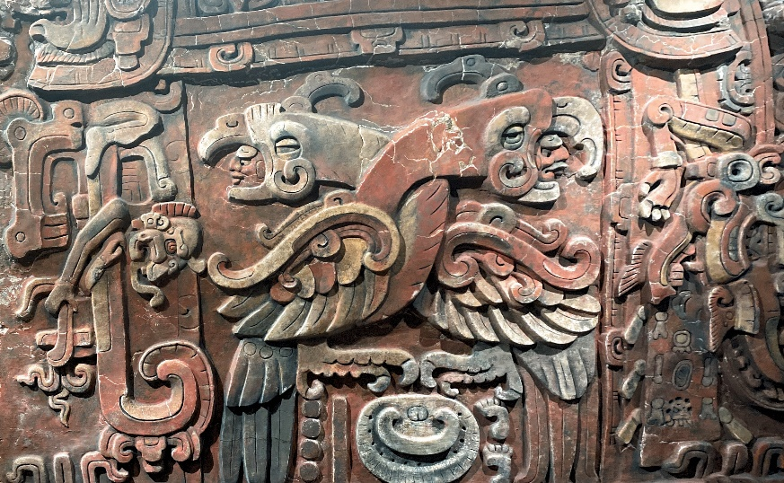
Above: Maya Margarite sculpture, Penn Museum’s collection,
Photo by Albert Fried-Cassorla
Milestones in World Culture: A Personal View
A Course Taught at Temple University’s
Osher Lifelong Learning Institute (Olli) SYLLABUS - 10-1-24

Hello students!  I am excited to be teaching this course. It allows me to share my enthusiasms and to learn from your experiences. Through this course -- and despite the daily headlines -- I hope you will have a more optimistic view of what we can achieve as human beings.  I look forward to seeing you in class!  Sincerely,    Albert Fried-Cassorla | 

Topic | Page number
Introduction and Summary | 3
Goals | 3
Goals & Expectations | 3
Expected Outcomes | 3
Texts I would like you to BUY or BORROW: | 5
About the Instructor | 5
OUTLINE with  Calendar and Brief Descriptions | 6

Introduction and Summary
Hello and welcome to my course and book on Milestones of World Civilization.
This 8-class and 8-chapter course will illustrate my view of the most significant events and achievements of humanity through the arts, over millennia. My view will sometimes adhere to the consensus opinion on cultural milestones and will sometimes reflect my personal opinions and predilections.
Since I have proposed such a broad reach, my selections will of course be individualized according to my enthusiasms. But they will also be justified. In addition, I will sample great works from multiple cultures including Western countries and places abroad ranging from Mayan to Japanese, Namibian and beyond.
Although my focus will be on the arts, I will also touch upon events in science, architecture, and more. Each tranche of history will have main highlights as well as subsidiary attractions. It will be supplemented by my collections of photos, videos and artifacts from my various world travels. Conspicuously absent will be most of the horrors which humanity has inflicted upon itself. Also missing will be most natural disasters.

Goals
The Goals of this course are:
- To give you a sampling of some of the most remarkable works of civilization
- To provide you with context and background information for further exploration, learning, and travel
- To provide and antidote or counterbalance to negative news
- To enrich your life and give you pleasure
- To give you more reason to be proud to be a human being

Expected Outcomes
- You should feel that this course has added to your knowledge of major cultural treasures.

Expectations for your participation
- I hope you will read the assigned texts or videos and contemplate their meaning.
- On occasion, I will give you optional homework. Some homework assignments will be designed to make class more engaging. If you volunteer to complete this kind of assignment, please follow through. Examples are: volunteering to read texts aloud, or to pre-analyze and present a text selection in class.
- Bring your thoughts and reflections to class and be prepared to share them,

Recommended texts:
If at all possible, please purchase or borrow:

History's Timeline Revised and Updated: a 40,000 Year Chronicle of Civilization
by Jean Cook $13.88 hardcover. This book will enable you to place various events in an understandable timeline, all at a glance. It covers multiple cultures.

Civilisation: A Personal View, by Kenneth Clark, Available on Amazon.com $10.70 hardcover, $6.33 paperback. I encourage you to also watch the BBC 13-part series with English subtitles on youtube.com. This book will give you an authoritative but highly opinionated view of culture through the millennia.

Expected Outcomes
I hope that you will be both edified and entertained by this course. You may be able to incorporate this historical and cultural viewpoint into your travels and readings.

About me, your Instructor: Albert Fried-Cassorla
My relevant background experiences include studying as a Senior Scholar at the University of Pennsylvania, where I presented a talk on ancient Greek pottery, and where I took numerous history and related courses. I also studied at Temple University’s Senior Scholar program, taking courses in Art History and Modern Art. I plan to use the treasures of our fabulous city as a focus for historical exemplars. I hold an MFA in Writing from Columbia University and have taught at Temple University, Gwynedd Mercy University and the School District of Philadelphia.

Milestones SYLLABUS as of 10-1-24

Ideas and Eras for 10 Classes – Outline Only
Note that this outline is a work in progress. I will continuously revise it and keep you informed.
“WEE” explained
The Ideas or lenses to throughout this course are crystalized by the acronym WEE. Thise initials stand for Wisdom, Esthetics, and Ethics.

Esthetics – Beauty Beheld - What is Beauty?
This is of course, an age-old topic. One person’s ideal of beauty may be another’s example of extreme ugliness.
How does it affect us? What is celebrated or derided here?
Morals: 7 Deadly Sins, 7 cardinal virtues

NOTE: No class will be held on Thursday, October 3rd, 2024 due to Rosh Hashanah being observed (Olli schedule says no classes should be held on that date.)

- Thursday, 10/10/24 –Course Outline, Cosmological and Human History
(note: This lesson description is more detailed than others in this course.)

Our course begins with a strange comparison: the history of our universe beside the length and breadth of human history.
The purpose of this comparison, as you have probably guessed, is to demonstrate how exiguous has been our tenure on this orb we call Earth. The scale of the universe makes earth-time seem tiny.

Think of it: billions of years as frame of reference compared with our puny 200,000 years as a species, or even 2 million years as a branch of hominids. The scales are clearly of a different order. Yet somehow we (or I) find these scales of time useful. They point out that we are but a speck in the continuum of time. But, we are a significant speck, I argue. We are significant to ourselves, and that counts.
You might wonder why I am beginning a history of human cultural milestones with some notes on astronomy. Why indeed? First, because I can. Second, because it provides for a more complete setting for our human accomplishments. Our whole parade of DNA and evolution stands as a lively exclamation point in a world of carbon, cinders and unimaginably powerful explosions.
The model of the beginning of the universe is called the Friedmann–Lemaître–Robertson–Walker (FLRW) metric. Note that this metric is called inadequate to describe what has actually happened. So even scientists lack the knowledge to comprehend this super-massive event,

History of the Universe via wikipedia
https://en.wikipedia.org/wiki/Chronology_of_the_universe
If we look at the history of the Universe as presented by en.wikipedia.org, we see that most of our history happened in the first 1 billion years out of its 13.8 total billions of years of existence.
Philosophically, it is disturbing to some of us that the universe reached an inflection point at 5 or 6 BYA. The Universe simply expanded without stopping! You might think it would be better behaved. How do you feel about this?

Our Solar System formed 9.2 BYA. Do you feel sentimental about this? I recall seeing an animated film in grade school called Our Mr. Sun. It was made in 1956 by famous director Frank Capra and had high production values for its era and lots of charm.
Let’s look at these key cosmological facts together and try to fathimwhatb they mean to us in their epic and almost muthical sigfnificance.
13.8 B years ago - Universe and Birth of Earth ––Pre-condition for culture and anything
4.6 BYA – Birth of the Earth
4.5 BYA - Birth of the Moon
2 MYA – hominids appear
200,000 YA – homo sapiens
Human History and Pre-History, 2,000,000 to 200,000 years ago
64,000 YA – Cave art appears
--------------
Universe and Birth of Earth – 13.8 B years ago –Pre-condition for culture and anything
Human History and Pre-History, 2,000,000 to 200,000 years ago
Human Evolution – Cave Art (60,000 BCE)
Origins of writing
Writing – focus: The Epic of Gilgamesh overview, reading and read-aloud
Gilgamesh Overview - https://en.wikipedia.org/wiki/Epic_of_Gilgamesh (first 5 paras)
Gilgamesh text - http://www.aina.org/books/eog/eog.pdf

Youtube lecture by Lecture by Andrew George,

https://www.youtube.com/watch?v=Rd7MrGy_tEg
pay from 44:38 to 56:01 (12 min.)

- Thursday, 10/17/24 – Lesson 2 – Shelley’s Ozymandias & the Songs of Songs
Song of Songs
https://www.jewishvirtuallibrary.org/shir-hashirim-song-of-songs-full-text
Flood stories compared
Other Ancient texts – compare with Genesis
Ozymandias – Shelley
https://www.poetryfoundation.org/poems/46565/ozymandias
Enheduanna – see Photomyne, JP Morgan
Code of Hammurabi – 1755-1750 BCE
Cuneiform – see National Geographic History magazine article

3) Thursday, 10/24/24 – Lesson 3 - Greek History – The Parthenon, 5th century BCE
Sappho
Pericles’ Funeral Oration
https://en.wikipedia.org/wiki/Pericles%27s_Funeral_Oration
https://sourcebooks.fordham.edu/ancient/pericles-funeralspeech.asp
Greek Mathematics -
The Parthenon & Elgin Marbles
Buddha, 500 BCE, Taoism, Leo Tse 571 BCE
Christianity & Jesus – 1st century AD

4) 10/31/24– Lesson 4 - Pompeii, Pliny the Younger, Eruption of Mt. Vesuvius 79 AD, preserved buildings, relics and art
Pompeii
Destruction of the Second Temple. 70 CE
Pre-Columbia Civilizations
Middle America - Teotihuacan
The Pre-Columbian
Penn Museum – Margarita Panel 500 Ce approx.. See Photomyne

5) 11/7/24 Lesson 5 - High Middle Ages:
700-800 Temples near Chennai
Hildegard von Bingen (1098 – 17 September 1179) writer, composer, philosopher, mystic, visionary.
Dante c. 1265 – 1931- Inferno (Pinkney’s translation)
Also: Boccaccio, Petrarch -
Satyricon by Petronius = Tramalchio’s Feast, gluttony
Duc de Berry, The Book of Hours, See Photomyne, The Tres Riches Heures of Jean, Duke of Barry
As presented in Civilisation, Episode 3,
https://www.youtube.com/watch?v=_lp-ZFKUbO8 13:22 – 19:56 – (6:34 min)

6) 11/14/24 – Class #6 - Renaissance & Baroque
The Vatican, Sistine Chapel, 1473 and 1481
See my photo collection on the Sistine Chapel - slide
Roman Art, Bernini (1598-1680), Apollo & Daphne
SmartHistory https://www.youtube.com/watch?v=bdnPdZMZ9PU
Native American Migration, Teotihuacan (1- 500 CE) Mayan, Zapotec and other cultures
Angkor Wat, 12th Century
Compared to BAM temple on NJ near Trenton.

11/21 & 11/- NO CLASS

7) 12/5 – Class #7 - Baroque Era - 1567 –Monteverdi, Handel, Bach, Vivaldi, Telemann, Albinoni
Architecture & Science: TBD

8) 12/12/24 – Class #8 – Enlightenment & Romanticism: Philosophy: Descartes, Hume and Kant, selected modern topics
Enlightenment:
Descartes, Hume, and Kant
Mozart, Beethoven
Invention of the Orrery, device for illustrating celestial movement – 1710 – a marvelous example exists on display at the university of Pennsylvania’s Van Pelt Library.
Romanticism –
Romanticism, Romantic era: August Rodin (1840 – 1917), Doors to the Gates of Hell, Burgers of Calais
Trevi Fountain
Wordsworth, I Wandered Lonely as a Cloud (Daffodils), Tintern Abbey, and The Prelude, (7 April 1770 – 23 April 1850)
Other: Byron, Blake, David, Goethe’s Faust, Beethoven
Note: Class #9 will not be offered this semester (Fall 2024). It is listed below in case you would like to pursue these topics on your own.
------------------------------------------------------------------------
9) Class #9 - 20th & 21st Century
T.S. Eliot “The Love Song of J. Alfred Prufrock”
Declaration of the Rights of Man
Other: aspects Modernity, (NOT World Wars. Holocaust, Nuclear Destruction, except brief nods) Flight, modern wealth, medical advances, Internet, literacy

